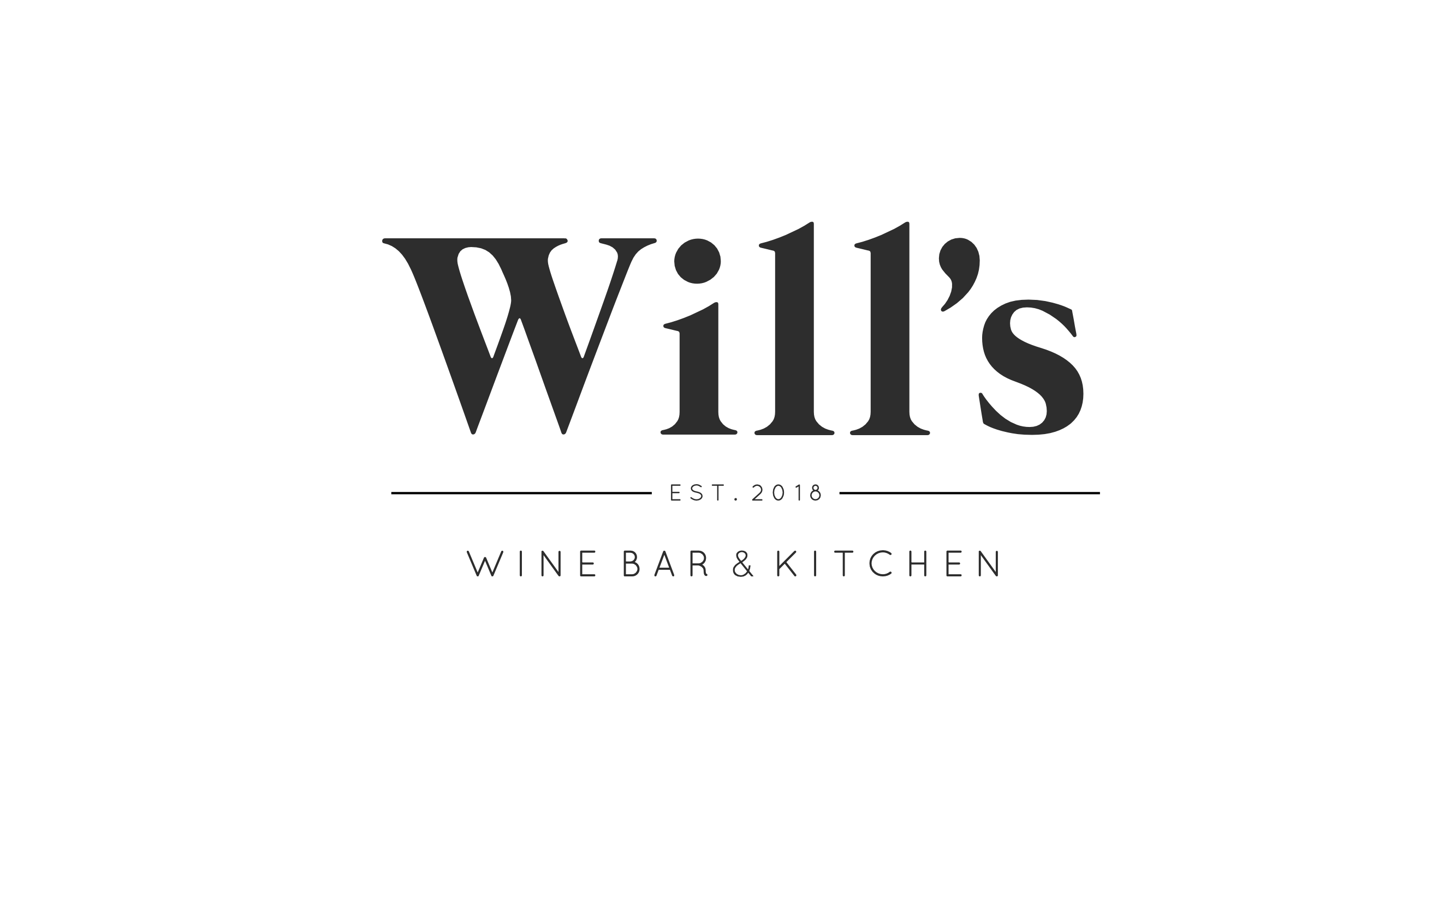
Sunday Lunch Menu

2 course – 30
3 course – 35

Nibbles
Mixed marinated olives (VE) (GF) – 5
Padron peppers, whipped tahini, Maldon sea salt, lemon (V)(N)(GFO)(VEO) – 6.5

Starters
Canadian maple & mustard chipolatas
Jalapeño bottlecaps, Japanese breadcrumbs, whipped sour cream, chives, lemon (V)
Sausage roll, English mustard, onion chutney
Halloumi fries, Japanese breadcrumbs, chili jam, mint yoghurt, sesame, lemon (V)
Will’s fried chicken, hot honey ranch, pickled chili, lime

Mains
roasted rib of Ribble Valley Hereford beef, red wine beef sauce
French trimmed chicken breast, sage and onion stuffing, thyme and chicken sauce
Nutless roast, mushroom, pumpkin and sunflower seeds (V)

All of our Sunday roasts are served family style with traditional trimmings;
Yorkshire pudding, roast potatoes, honey glazed carrots, roasted green veg and cauliflower cheese

Desserts
Sticky toffee pudding, Lancashire red toffee sauce, Madagascan vanilla ice cream
Tiramisu, rum soaked Naple biscuits, marscapone, chocolate
Triple choc brownie, cherry coulis, Madagascan vanilla ice cream (GF)

(V) vegetarian (VO) Vegetarian option available (VE) vegan (VEO) vegan option available
(GF) gluten free (GFO) gluten free option available
(N) contains nuts
please inform the staff of any allergens or dietary requirements

